# Lab: Introduction To Bootstrap

## Grid System

Create a Web Page like the following:



### Constraints

* Look Bootstrap grid system documentation and play with it: [Click here !](https://getbootstrap.com/docs/3.3/css/#grid-example-basic)

## Navigation Bar with Jumbotron

Create a Web Page like the following.

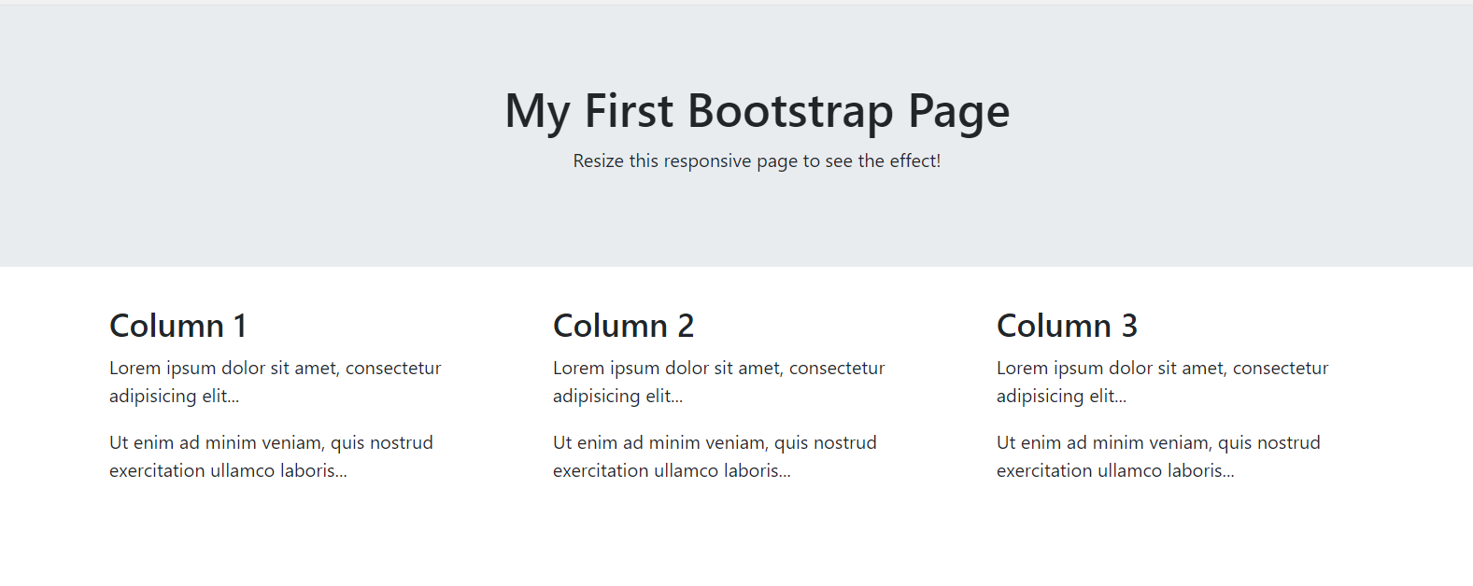

Create one file: **"nav-bar.html"**.

### Constraints

Include this link to your header:

**<link rel="stylesheet" href=**

**"**[**https://maxcdn.bootstrapcdn.com/bootstrap/4.0.0-beta/css/bootstrap.min.css**](https://maxcdn.bootstrapcdn.com/bootstrap/4.0.0-beta/css/bootstrap.min.css)**"/>**

* Search for:
  + **class**="jumbotron text-center"
* Create three columns like this:

